Звіт з бд

лр 4(5,6,7)

Гніздовський Максим

запити до монго(20 одиниць):1.db.Cars.find({ make: "Mazda" });

2.db.Cars.findOne({ _id: ObjectId("6641b15c30d8b6103eea1d9e") });

3.db.Cars.count({ make: "Mazda" });

4.db.Cars.find();

5.db.Cars.aggregate([

{ $match: { make: "Mazda" } },

{ $group: { _id: null, averageYear: { $avg: "$year" } } },

{ $sort: { averageYear: 1 } } ])

6.db.Cars.insertOne({

make: "Toyota",

model: "Camry",

year: 2023

});

7.Cars.aggregate([

{ $match: { make: "Subaru" } },

{ $group: { _id: null, averageYear: { $avg: "$year" } } }]);

8.db.Cars.aggregate([

{ $match: { make: "Subaru" } },

{ $group: { _id: "$model" } }

]).toArray();

9.db.Cars.aggregate([

{ $match: { make: "Mazda" } },

{ $group: { _id: "$model" } }

]).toArray();

10.db.Cars.aggregate([

{ $match: { make: "Subaru" } },

{

$group: {

_id: null,

averageYear: { $avg: "$year" },

averageId: { $avg: "$_id" } }

}

])

11.db.Cars.deleteMany({ year: { $lt: 2016 } });

12.db.Cars.find({}, { make: 1, model: 1, _id: 0 });

13.db.Cars.updateMany(

{ make: "Ford" },

{ $set: { year: 2022 } }

);

14.db.Cars.find().sort({ year: 1 });

15.db.Cars.countDocuments({ year: 2019 });

16.db.Cars.distinct("make");

17.db.Cars.insertOne({

make: "BMW",

model: "320i",

year: 2024

});

18.db.Cars.aggregate([

{ $group: { _id: "$make", count: { $sum: 1 } } }

]);

19.db.Cars.updateOne(

{ _id: ObjectId("6641b15c30d8b6103eea1d9e") },

{ $set: { model: "CX-5" } }

);

20.db.Cars.updateMany(

{ make: "Ford" },

{ $set: { year: 2022 } }

);

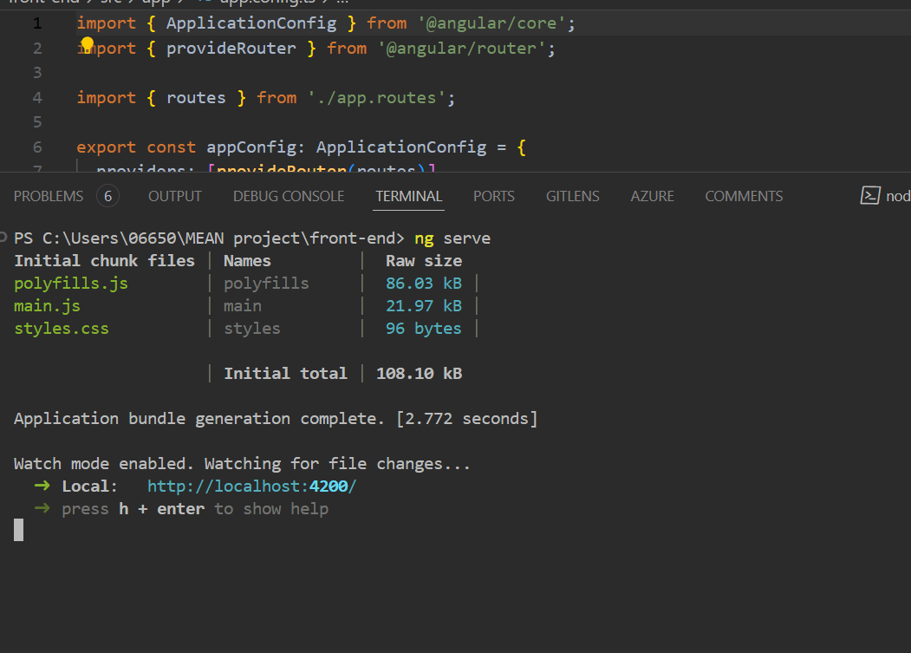

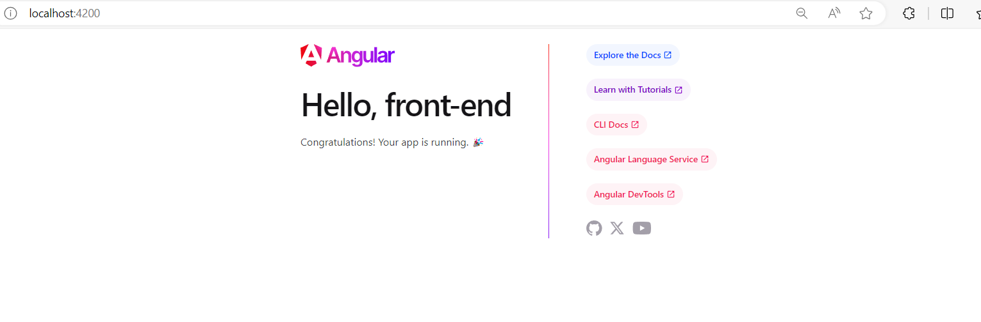

Але на жаль не зміг підтянути фронт

повний mean проект з ендпоїнтами буде викладений